**WARMINSTER** **MARCH**

**UNITED 2014**

**CHURCH**

**(Methodist /URC)**

**George Street**

**BA12 8QA**

**Minister: Bookings**

**Rev David Coppard & room hire**

**Tel: 01373858805 Tel:** **07900661789**

[**dave.coppard@virgin.net**](mailto:dave.coppard@virgin.net)

**www.unitedchurchwarminster.org.uk**

Dear Friends

I recently perused an old envelope full of cards and letters which were sent to my late parents on the occasion of the birth of my sister and me. It was fascinating not only to see the stamps and postal charges of the 1960’s, but to look at the cards style and especially read what people had written. As well as congratulations, time and again the statement appeared, “we hope your new arrival will bring you joy and happiness.”

That has made me reflect, what would those who wrote those words think of where I am in life and of my life journey thus far? Would they feel their hopes had been fulfilled or would there be disappointment? Life for all of us is a journey and I am reminded of words attributed to the Quaker missionary, Stephen Grellet:

***“I expect to pass through this world but once. Any good thing, therefore, that I can do or any kindness I can show to any fellow human being let me do it now. Let me not defer nor neglect it, for I shall not pass this way again”.***

Within the Gospels we meet Jesus, God incarnate and we recall his ministry, death and resurrection. We look to Jesus for inspiration and guidance, but time and again within the New Testament there is challenge. We are called to follow in the ministry of Jesus ourselves, seeking to show attributes of his ministry within the mission and service both of our Churches and ourselves.

One of my friends wears a wristband with WWJD: *What would Jesus do!?*

We are each Christian ambassadors and that is most certainly not just when we are in Church, rather especially when we are not! The sixteenth century Carmelite nun, Teresa of Avila put it succinctly:

***Christ has no body but yours,  
No hands, no feet on earth but yours,  
Yours are the eyes with which he looks  
Compassion on this world.  
Yours are the feet with which he walks to do good,  
Yours are the hands, with which he blesses all the world***

In all that we seek to do, may we mirror Christ!

Shalom Rev David Coppard,

**MAUNDY THURSDAY**

**Agape soup supper**

**followed by a service**

**led by Rev. David Coppard**

**C:\Users\Joan and Evan\AppData\Local\Microsoft\Windows\Temporary Internet Files\Content.IE5\PMEVJWOC\MC900098093[1].wmf**

**GOOD FRIDAY – 18TH APRIL**

**A short act of witness and worship will take place**

**outside**

**St Lawrence’s chapel**

**starting at 10am**

to be led by members of our church.

**This will be followed by**

**the Walk of Witness**

to each of the churches through the town with a prayer outside each church.

The route will be:

Start: St Lawrence’s chapel then to 2. Christ Church t 3. United Church 4. The Minster 5. Baptist’s Church 6. Grace Centre - Foundation Christian Fellowship 7. St John’s Church 8. St George’s Catholic Church Everyone is invited to join in at any point of the walk

There will also be **meditations** in various churches – look out for details.

C:\Users\Joan and Evan\AppData\Local\Microsoft\Windows\Temporary Internet Files\Content.IE5\1O9DLB4Z\MC900361874[1].wmf

**EASTER SUNDAY**

David Coppard will lead a short

**Meditation at 8.45 a.m.**

This will be followed by **Breakfast** at 9a.m. **,** as is the tradition of our church. This is being organised by Karen Woollard this year.

**The Easter Sunday Service at 10.30 a.m.**

**will be lead by Rev David Coppard**

Starting Soon

**MIDWEEK SERVICES**

Every Wednesday Morning

From 10.15 to 10.45

Once a month there will be a

**Communion Service**

All service will be followed by Coffee

**Ecumenical Lent groups**

**Ivy House** each Sunday in Lent  from 9 March 4.30pm – 5.30pm. Looking at the Churches Together in Britain and Ireland - “Parables & Possessions.” The study can be downloaded from [ctbi.org.uk](http://ctbi.org.uk/" \t "_blank) Lent 2014 Study.

**Minster Church** - Tuesdays 7.30 p.m.

**St John’s vicarage** - 50 Gypsy Lane Thursdays 7.15pm.

**Christianity in Warminster Exhibition**

This Exhibition will be in the Library during June. A time line will show significant information about each church (in words and pictures) ending with the work of Churches Together in Warminster.

**Cornerstone**

This Charitable operation is grant funded and will help vulnerably housed people. It is expected that it will to be up and running later this year with two volunteers and a trustee at the house for every session. The organisers would like to have a trustees from each church. If there is anyone from our church who would be interested in taking this on, or of helping in any way, then please have a word with Karen Woollard.

**Breakout**

Young people from three local churches have been meeting together for two years doing Good Deeds for the community. This year they joined in with the Carol Service and people engaged in conversation with the young people about their Christianity.

The young people are planning an Easter Egg Hunt in the park on Palm Sunday. Adult help with this and other events being planned for the summer is needed

**It was agreed at a previous church meeting that it would be helpful to new members and visitors to have a photo board of members & regular attendees at Warminster United Church.  Planning for this is underway.**

**The theme of the board will be based on John ch15 v5:**

**" I am the vine; you are the branches."**

**We will be taking  photographs on Sundays 30th March & 6th & 13th April. If you visit members that are not able to attend services please could you let me know.**

**Many thanks Penelope Harrison**

**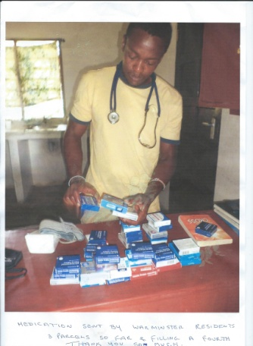**

**KENYAN MEDICAL CENTRE** is still in need of those pain relieving tablets.

If you are able to donate one or two packets regularly it would be greatly appreciated.

I will deliver to the lady who sends them out to Safari, the doctor who is working in the centre.

THANK YOU VERY MUCH. Marion Barton

**Christian Aid week 11th to 18th May**

The week begins with **Joint worship at 3p.m on 11th May** . This will be at St John’s Church and will include the Commissioning of all the collectors, this will be led by Bishop Ramsey.

During the week there will be a **Quiz Night at the Organ Inn** to raise money for Christian Aid. Donations of Raffle prizes would be welcome.

On **27th April, 3.30 to 5pm** there will be a **Christian Aid Tea and Scones at Bishop Ramsey’s House**

On **June 6th** there will be a **Dinner in the Civic Centre** costing £15 a head, proceeds to Christian Aid.

Watch out for more details of all these events.



**Women’s World Day of Prayer - 7th March**

There is no service in Warminster this year but all are welcome to attend services at **Upton Lovell at 7.30 p.m**. or St **Bernadette’s Catholic Church in Westbury at 2.30 p.m.**

Churches Together in Warminster propose that from next year there will be a **World Wide Day of Prayer** in the town in place of the Women’s Day of Prayer.

**Imam’s Visit**

Churches Together in Warminster have invited Imam Wali Ruhman to come and talk about the Muslim faith; explaining what Islam is , how it works and how we can all work together to bring more understanding and peaceful relationships.

This meeting will be held at our church soon, the exact date is not yet fixed. All will be welcome.

There will be refreshments provided from “Paprika” restaurant opposite the church.

**2014 COFFEE MORNINGS**

|  |  |  |
| --- | --- | --- |
| **January 11th** | **MedAir** | **£96** |
| **February 8th** | **Foodbank** | **£150** |
| **March 8th** | **People Against Poverty** |  |
| **April 12th** | **Alzheimer’s Society** |  |
| **May 10th** | **Christian Aid** |  |
| **June 14th** | **Freedom Charity** |  |
| **July 12th** | **Brain Tumour research** |  |
| **August 9th** | **Action for Children** |  |
| **September 13th** | **Rwanda Education Project** |  |
| **October 11th** | **ZWSF** |  |
| **November 8th** | **Shoeboxes** |  |
| **December 13th** | **Wessex Heartbeat** |  |

**All coffee mornings are 10 a.m. to 12 noon**

I am visiting the Project supported by **People against Poverty** in Iasi, **Romania** , in May. The proceeds of March’s coffee morning will be used to buy groceries etc to take to families that we visit while we are there, so you can be sure that all money will go directly to some of the poorest people in the slums of Iasi and its surrounding villages.

Joan Jones

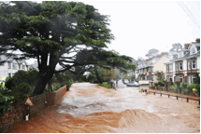**[South-Western Synod calls for prayers of support and justice amidst severe flooding](http://www.urc.org.uk/media-news/1341-south-western-synod-calls-for-prayers-of-support-and-justice-amidst-severe-flooding.html" \t "_blank)**

The Revd Ruth Whitehead, Moderator of the South Western Synod, urges people to join in prayers of solidarity with those whose lives and livelihoods have been damaged and disrupted by the on-going floods and storms in the south-west of England. Severe flooding and rough seas have wreaked havoc, disrupting businesses, severing road and rail links and

leaving families homeless.

**Ruth will be coming to our church on Sunday October 5th**

**HOUSE GROUPS**

In December the **Wendy House Group** drove together (very squashed) to Salisbury's Sarum College Bookshop to choose this year's study.  We decided on the book of James and are finding the very practical advice very helpful in our Christian learning journey.  We meet together on the first Monday in the month & our fellowship is warm and friendly, though we do miss having Denis Stephens with us this year.

Karen Woollard

**The Cooper House Group** still meets once a month when enough members can make the date selected. We are few in number these days and would welcome some new members. We meet on a Monday evening but that may not be set in stone! We usually follow a bible study guide but for the last few sessions we have had a DVD with an opening talk and then questions. We shall probably choose a study guide again in the next couple of months.  
Pam and Derrik Copeland

**SUNDAY SERVICES 10.30 A.M.**

**MARCH**

2nd : Rev Mary Teed

9th : Rev David Ellis

16th : Pauline Tiller

23rd : Rev David Coppard HOLY COMMUNION

30th : Tom Hill

**APRIL**

6th : Rev David Coppard HOLY COMMUNION

13th : Local arrangement ( see weekly notices for details)

20th : Rev David Coppard HOLY COMMUNION EASTER DAY

27th : Clive Illman

**MAY**

4th : Rev Heather Morgan

11th : \*

18th : Local arrangements ( see weekly notices )

25th : Rev David Coppard HOLY COMMUNION TRIO SERVICE

\*Roger Simmonds, who sadly died recently, was due to take this service. Alternative arrangements will be announced on weekly notice sheet.

**GLADYS TURNER 1910 to 2014**

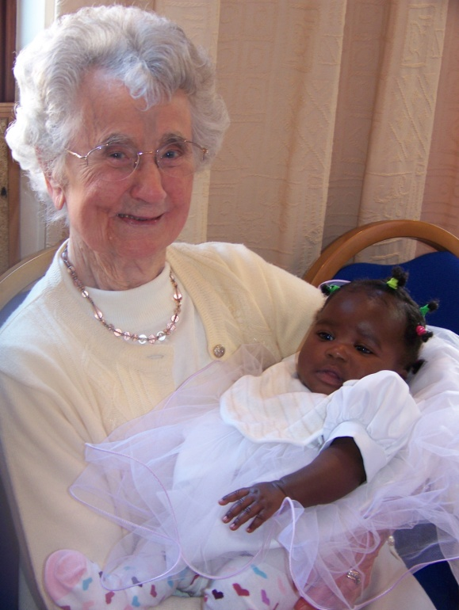

Gladys Turner with baby Gladys Enos at her christening in 2008

Gladys’ great faith upheld and sustained her throughout her long life. From her childhood in London’s East End and school days during the First World War, through her working days as a bookkeeper, her 35 years of happily married family life with Bertie and their sons and her sudden widowhood in 1974, through to more recent years here in Warminster. Her family grew to include many grandchildren and great grandchildren. She showed great love and interest in all of her family, proudly keeping us all informed of the arrival of another great grandchild. At her 100th Birthday party she was talking with excitement of a grandson’s wedding coming soon after.

Gladys was a much loved member of our community a Warminster United Church. In her earlier years with us she enjoyed being involved in Sunday worship, often reading the lesson, and in the house group which regularly met in her home.  She also helped run the Tuesday afternoon fellowship which meant a lot to her, she was very upset when it finally closed.

When she was no longer able to join with us in worship at church she still put aside the hour on a Sunday morning to join with us in spirit, singing the same hymns as we did, reading the same Bible passages and if possible the sermon.

She loved having visitors and made all welcome with tea and biscuits, and often her famous rock cakes or scones, which she continued cooking until the last couple of years – coffee mornings are not the same without those rock cakes!

 Gladys was a person of deep faith, she was brought up in a Brethren based family and her faith was her rock.

She is now in God’s safe keeping .

Church Rota for April, May and June 2014

|  |  |  |  |  |
| --- | --- | --- | --- | --- |
| APRIL | Open/Vestry | Books/Welcome | Coffee | Flowers |
| 6th | Barry O/V | Margaret Edwards and Jenny Sanderson | Hilda Hanks and Joan Stephens | Helen Mills |
| 13th | Marion O/V | Marion and John Hornby | Debbie and Denis Major | Helen Dawson |
| 20th  Easter | Brenda O  Margaret McD/ V | Karen Woollard and Mike Evans | Brenda and Ron | Easter Flowers |
| 27th | Karen O/V | Nelda Spooner and Hilda Hanks | Mary and Barry | Joan Jones |
| MAY |  |  |  |  |
| 4th | Marion O/V | Jenny Sanderson and Margaret Edwards | David and Yvonne Syrett | Joan Stevens |
| 11th | Joan Stephens O  Karen Woollard V | Andy Simmons and Joan Stephens | Diana and Wendy | Sandra Matthews |
| 18th | Joan Jones O  Margaret Mac- Donald V | Pat and Dennis Mills | Joan and Evan Jones | Pat Mills |
| 25th | Karen V/O | Sandra Matthews and Hilda Hanks | Debbie and Dennis Major | Marion Thornby |
| JUNE |  |  |  |  |
| 1st | Hilda O/V | Pam and Derrick Copeland | David and Yvonne Syrett | Joan Agnew |
| 8th | Helen O/V | Marion and John Hornby | Mary and Barry | Wendy Wormesley |
| 15th | Hilary O/V | John and Stella Case | Pam and Derrick Copeland | Pam Copeland |
| 22nd | Barry O/V | Penelope and Jack | Brenda and Ron | Helen Mills |
| 29th | Diana O  Karen V | Margaret Edwards and Jenny Sanderson | Diana and Wendy | Kate Skillman |

March rota as in last issue of Newsletter

**STEWARDSHIP**

Stewardship is about the relationship between Christian living and Christian giving. It is the response to God’s giving in Jesus Christ. It is about giving, about giving ourselves, without reserve , to achieve God’s purpose of love. Stewardship acknowledges that all that we have first comes for God and then poses the question ‘How do we respond and use the gifts that He has given us?’

TRIO is a financial giving programme. However it can easily be adapted by churches who are trying to gather together the resources necessary for a mission project or who are seeking to move forward to achieve a vision of being a mission based church.

Here ,at Warminster, we shall examine TRIO on Sunday 25th May during the morning service. Please note the date in your diaries.

John Hornby

**MAD HATTER’S TEA PARTY**

**March 23rd - 2.40 to 4.30 p.m.**

**Christchurch**

**Afternoon tea and fun in aid of Sports Relief**

**to help needy children in Britain and around the World**

**Tickets from Penelope Harrison- 01985 212200**

**Adults £3, children £1.50**

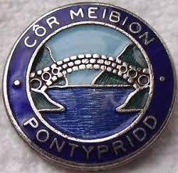

**PONTYPRIDD MALE VOICE CHOIR**

Holt URC

26th April - 7.30p.m.

Tickets & details Myra Green 01225863628



**JANE AUSTIN TEA PARTY**

St Andrew’s Church Devizes

17th May 3 p.m.

Tickets £5 – Cynthia 01380 726373

**CHURCH FAMILY NEWS**

As we celebrate the life of Gladys Turner so we also remember our friends who can no longer join us each Sunday for worship; Including Audrey and Howard, Margaret and Tony, Ivy, Daphne Coles, John Hewitt, Bernard Cooper in Bratton and Barbara Spooner in Hampshire.

I am also mindful of the army families in Warminster who with their busy lives in the military and families to care for, find it difficult to get here to worship with us.

To each and every one celebrating their birthdays in the next few months – Happy Birthday! – And especially Ruth who has a March birthday and will be 68 years old.

Please pray for Jenny’s son Edison and Catherine who are expecting twin girls in May. Our thoughts go with them both as they anticipate this happy event.

In memory of friends, Kevin and Marion have signed up for the Thames Challenge Walk in September. Walking 25k from Cookham to Henley, it should be a delightful adventure – but with the flood waters of the Thames breaking all known records, one wonders if the path will still be there! They will be seen this summer, striding out on practise walks with their support vehicle (thank you, Helen) ready to collect them if the need arises. Bear with them if they approach you for sponsorship as they have agreed to raise funds for research into breast and bowel cancer.

Marion Barton

PLEASE LET MARION KNOW OF ANY NEWS OR CONCERNS IN YOUR FAMILY YOU WOULD LIKE TO SHARE

**The Foodbank in Warminster** is  now well  established, we are as busy as ever. The United Church can feel proud, in that many of the volunteers  are worshipers here. BUT the Foodbank was set up to feed all people in short term crisis, irrespective of Age, colour sex or creed, provided they are referred by a distributor who has accessed their need. Much of the food received is donated by folk with just a feeling to do the right thing and help their neighbour.

**Since the start of the financial year 2,148 local people have been fed, 900 being children.**

**Volunteers packed 154  Christmas " goody " bags for nominated families. We fed a family who just before Christmas lost their home in a fire. The Foodbank   also helped at Christmas lunches for people in need, and  sent food to Swindon Homeless centre , because they had run out of food**

Volunteers working in the Foodbank in North Row regularly meet people experiencing difficulties with benefit delay or changes. Many of our clients are in low paid work, struggling to meet an unpaid bill.  The Foodbank has close ties to the community hospital in Warminster we can provide "home from hospital" food boxes to unsupported people leaving Hospital.

Can we remind readers that Vouchers, for the exchange of food are available at many places around the town. e.g.  Churches, CAB School support workers , Doctors surgeries Royal British Legion, SSAFA Army garrison Padre office etc.

**The Foodbank  landline number is 01985 214463  mob 07855627945  The centre is open. Tuesdays Wednesday, Fridays  10am ‘til 1pm**.

**Fund raising events** for the costs of running the centre. include.

**Lent Lunch** at Christchurch Hall  Saturday 15th March  12 noon until  2pm

**Spring fair**       Civic Centre         Saturday  12th April   10 am ‘til        1pm

**Fashion show**    M and Co               Friday      26th September    7 pm

MANY THANKS FOR ALL THE SUPPORT WE RECEIVE  Jean Colgrave

**“GETTING TO KNOW YOU SUPPERS”** Many thanks to all who are already supporting these.

The idea of these suppers is twofold. Firstly sharing a meal together in the host’s home allows time to be spent together, with more time to chat and get to know each other than is possible after a church service.  Secondly, the guests who attend the meal are asked to make a donation in aid of a charity of the host’s choice (Suggested amount £5). I have hosted and been a guest and have really enjoyed the fun, fellowship and food!  
Please consider whether you would like to be involved; **both guests and hosts are needed!** **The meal or occasion is completely up to the host.** You may conjure up **lovely lunches**, be a dab hand at **dinners**, super at **suppers**. Perhaps you are a superb sandwich and scone maker and **afternoon tea** might be your forte– or bring out the bacon butties for a **brunch**! Please come and have a chat with me if you feel inspired to be a host or would like to be included in the guest list. Helen Dawson

**FACING THE GREAT UNKNOWN**

**By Gladys Turner**

**How wonderful the sky, when it is clear and blue**

**Especially in the morning , when day begins anew.**

**It makes us feels so happy , to get up and start our day,**

**Remembering God’s promise to be with us all the way.**

**And if, a little later, some clouds may then appear,**

**We know, within our heart of hearts, we still have naught to fear.**

**When evening time approaches and the sky once more is blue,**

**We look up high to see the starts in all their radiant hue.**

**As we settle down to slumber in peace, still free from fear**

**We know our heavenly Father is still so very near.**

**So if to a desert island I was ever forced to go**

**These thoughts would reassure me, to face the great unknown.**

Has Cinderella's time finally arrived?

The rear rooms of the building have long awaited refurbishment. Back in the late 1980's architects plans were drawn up to modernise, but these were put on hold. With the pre-school expected to vacate later this year it could be that there is the opportunity to create a suite of premises that serve the needs of both church and community.

In the near future **a vision afternoon**, with faith tea will be held. This will be your opportunity to view the premises and dream dreams of what you would like to happen. Further details will appear shortly, but in the mean time please would you give this proposal your careful and prayerful consideration.

Thank you. Rev David.